[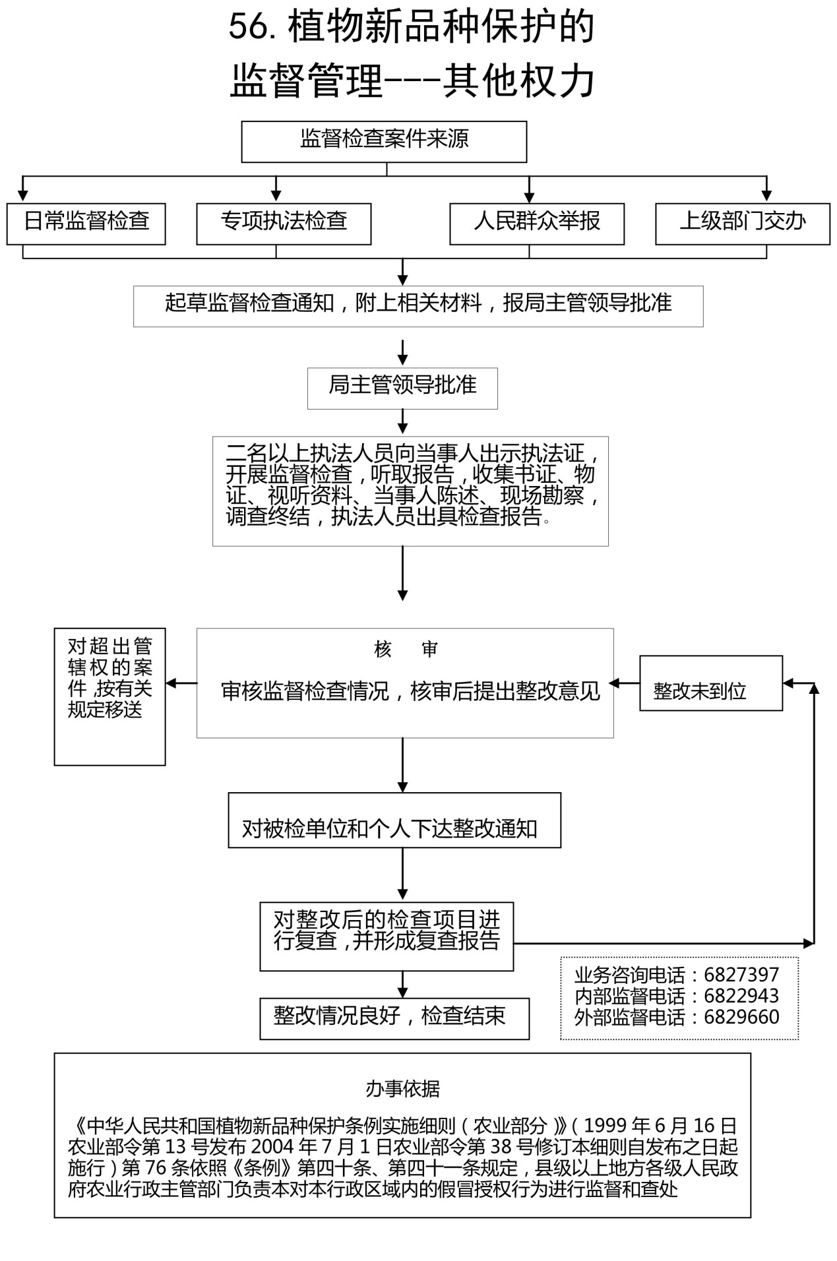](http://am.benxi.gov.cn/ql/up/2011916212435127.jpg)